Handout: Leading your team

The second in the ‘An introduction to middle leadership’ series from Bite Sized Training

# BEING EMPOWERED: ACTIVITY

* Working as a group, share your ideas on what the word ‘empower’ means in terms of leading your team.
* Individually consider your own role as a team leader:
* What actions do you take that empower your team?
* What actions might dis-empower your team?
* Share your thoughts with the group.

# HOW DO WE EMPOWER? ACTIVITY

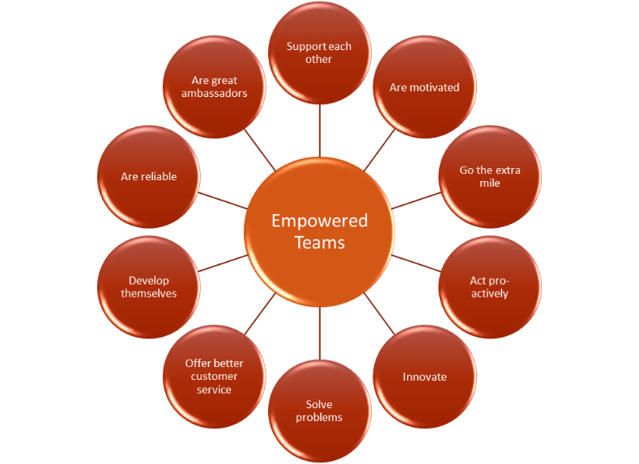Individually consider your own role as a team leader:

* What actions do you take that empower your team?
* What actions might dis-empower your team?
* Share your thoughts with the group.

## TEN STRATEGIES FOR EMPOWERING TEAM LEADERS: ACTIVITY

## Consider each of these ten strategies in turn:

* How would you evidence that you actively do each of these with your team?
* What steps could you now take to improve your team empowerment?

1. Give and receive feedback
2. Say thank-you
3. Ask for and listen to suggestions
4. Actively develop people
5. Expect more
6. Delegate
7. Trust and respect people
8. Be prepared to accept failure
9. Encourage career development
10. Monitor things

# SOUNDS LIKE A TRAP

Work in small groups to decide which ‘Traps’ do these scenarios relate to?

* You trusted a colleague to collate the end of year reports for a year group and they have split a mug of coffee over them. You are furious and are going to give them a piece of your mind
* 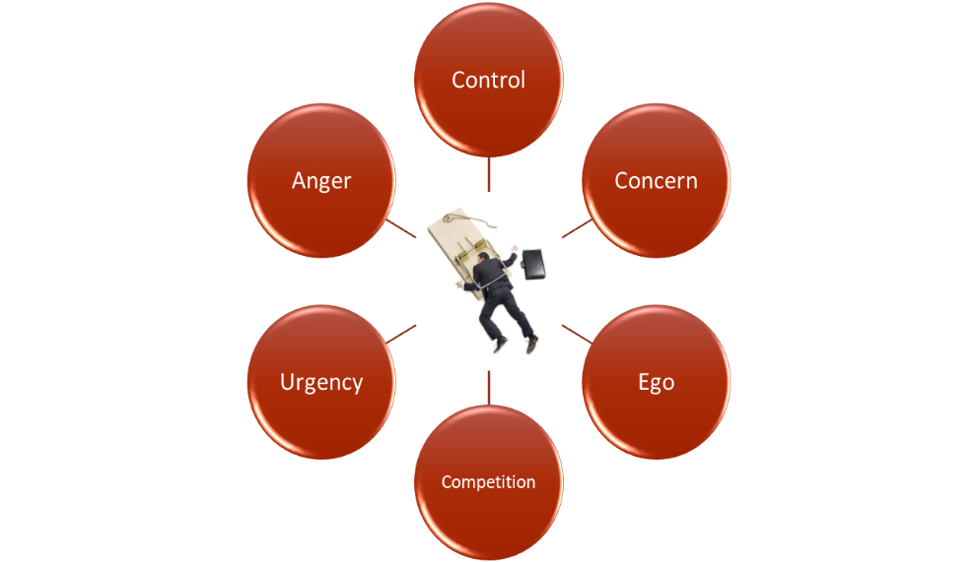You ask a colleague to plan a new unit of work but expect them to consult with you at each step of the way
* The school principal wants something on their desk by tomorrow morning. This is your team member’s responsibility, but you complete the task just to make sure it gets done on time
* You don’t want to ask a colleague to plan the next parent’s meeting because you know you can do a better job
* You are worried that, if you ask a colleague to take a lead role in a new project, they will think that you are passing the buck and you are lazy
* If you delegate too much, school leadership will see that someone in your team is better than you and they will get all of the credit

Now, for each one, agree a better team leadership strategy that will empower your team.

# MAKING IT WORK AT WORK: ACTIVITY

What will you do as a result of this Bite Sized Training?

Working in groups, look at the action sheet you have produced during today’s training.

* What are the three key learning points for you?
* What will you change tomorrow to improve your team leadership?
* How will you know when your change has been successful?