**HANDOUT: Handling Difficult People**

Building positive relationships with others

**INTRODUCTION**

Handling difficult people will focus on positive strategies to engage with people whose behaviour we might find challenging. By the end of this session, participants will be able to:

* Understand what we mean by difficult behaviour
* Suggest what might be driving the ‘difficult’ behaviour
* Use Transactional Analysis to take control of difficult behaviours and conversations

ACTIVITY

* Write a description or draw a pen portrait of a person whose behaviour, you feel, makes them difficult
* Share your ideas with a partner – can you identify any common features?
* Share these common features with the group and use the flip chart to record the group’s responses.

**WHAT IS DRIVING THE BEHAVIOUR**

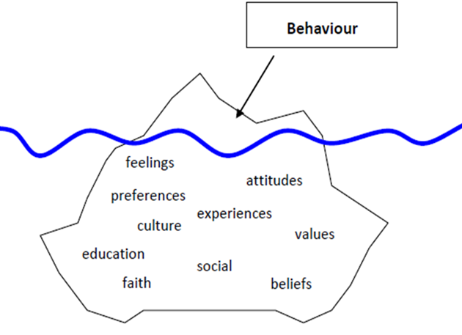**We don’t all react the same way to things because we are all different under the surface**

**NATURAL RESPONSES TO ‘DIFFICIULT BEHAVIOUR’.**

Eric Berne was an American psychologist who used transactional analysis to help people deal with ‘difficult’ behaviours.

Transactional analysis (TA) is a psychoanalytic theory where personal interaction are determined by the states of each person’s ego. Each of us can possess an ego in one of three states – parent-like, child-like, or adult-like). We can use this analysis as a way of understanding behaviours.

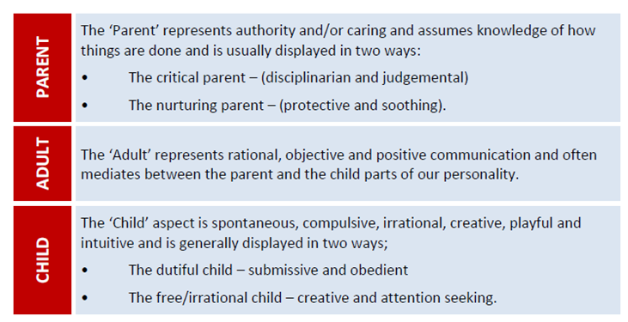

**Complementary transactions**

Psychologically, the easiest transactions between two people are complementary transactions, but they are not always appropriate. Just because someone speaks to you as a ‘critical’ parent, doesn’t mean a ‘dutiful’ child is the BEST response…just the easiest.

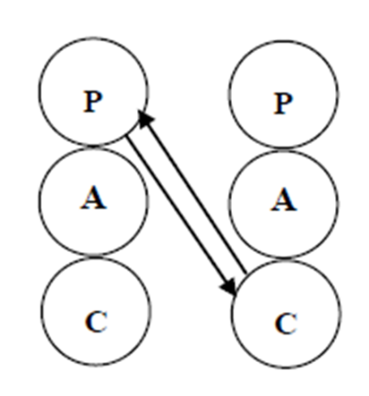**Crossed Transactions**

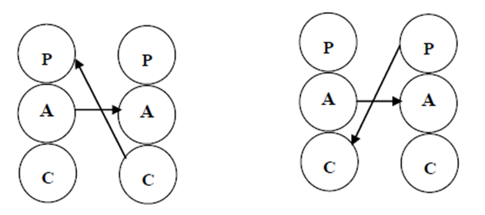If you resist the natural tendency to respond in a complimentary way, you can cause a ‘crossed’ transaction (by responding FROM the ‘adult’ and appealing TO the ‘adult). It is hard to maintain a crossed transaction, so eventually, you will find yourself in a complimentary transaction (adult to adult)

**Moving on**

In order to build more lasting positive relationships with people whose behaviours we find difficult, we need to:

* Remember that ‘difficult’ is often just ‘different’.
* Try not to judge people’s actions based on your personal values, belief and morals.
* Think about what might be driving the ‘difficult’ behaviour and respond to that. Sometimes people attack as a form of defence.
* Don’t respond in a way that will encourage the difficulty to persist.
* Respond in a calm, objective, ‘adult’ way as much as possible until the other person does the same.